User Guide for pptGenerator

Contents

Introduction 1

Preparation 1

Guide 2

1. Python script 2

2. Template PowerPoint 3

# Introduction

pptGenerator is a python script that helps the user to replace a QR code and text box in PowerPoint with a new URL link. It just needs a few presses to generate a PowerPoint that contains QR code and the URL link for a new course.

# Preparation

1. Download packages, pptGenerator.py, .env and template.pptx from [OneDrive SharePoint](https://gccprod.sharepoint.com/sites/CPFB-BIA-MST/Shared%20Documents/Forms/AllItems.aspx?id=%2Fsites%2FCPFB%2DBIA%2DMST%2FShared%20Documents%2FGeneral%2FPPT%20Generator&p=true&ct=1664501436780&or=Teams%2DHL&ga=1).
2. Open Command Prompt
3. cd C:\<your file path> to the file path where you save the above files.
4. Type cd packages and type python installer.py

# Guide

## Python script

After preparation, you must make sure you are in the path that contains pptGenerator.py.

Type python pptGenerator.py to open the script.

Figure 1. main page

General Steps:

1. Choose 1 to check the URL stored in the system if correct.
2. Choose 2 to edit the URL stored in the system. (Optional, only if you want to change form URL) (Check scenario No.1 for details)
3. Choose 3 to generate a PowerPoint. (Check scenario for details)

Scenarios (Optional, check this only if you are unsure):

Scenario 1. When you want to edit the URL stored in the system

Choose 2 in the main page.

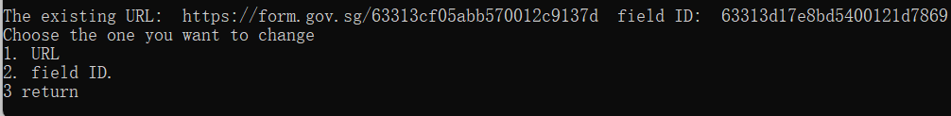

Figure 2. Editing URL and field id page

You will see figure 2 shown on the screen, and you are able to edit ether the URL or the field ID.

Figure 3. Editing URL

For example:

* 1. If I want to edit the URL / field id, I will type 1 / 2 in the Command Prompt
  2. You will see figure 3 on your screen and asking for the new URL / new field id
  3. Press Enter to save the changes, and you will be prompted that the new URL / field id is updated and returning to main page

Scenario 2. When you want to create a PowerPoint based on the URL stored in the system

Choose 3 in the main page.

Figure 4. Generating PPT

You should see figure 4 on the screen, ask asking for a course name.

In the example I typed introduction to python as the course name, and press Enter to continue.

Figure 5. PPT saved confirmation

You should see figure 5 on the screen which stating the path of the generated PowerPoint.

## Template PowerPoint

Only follow this guide if you want to change the layout of the template.pptx that download from the SharePoint.

The following example is based on the template.pptx that I provide.

Example:

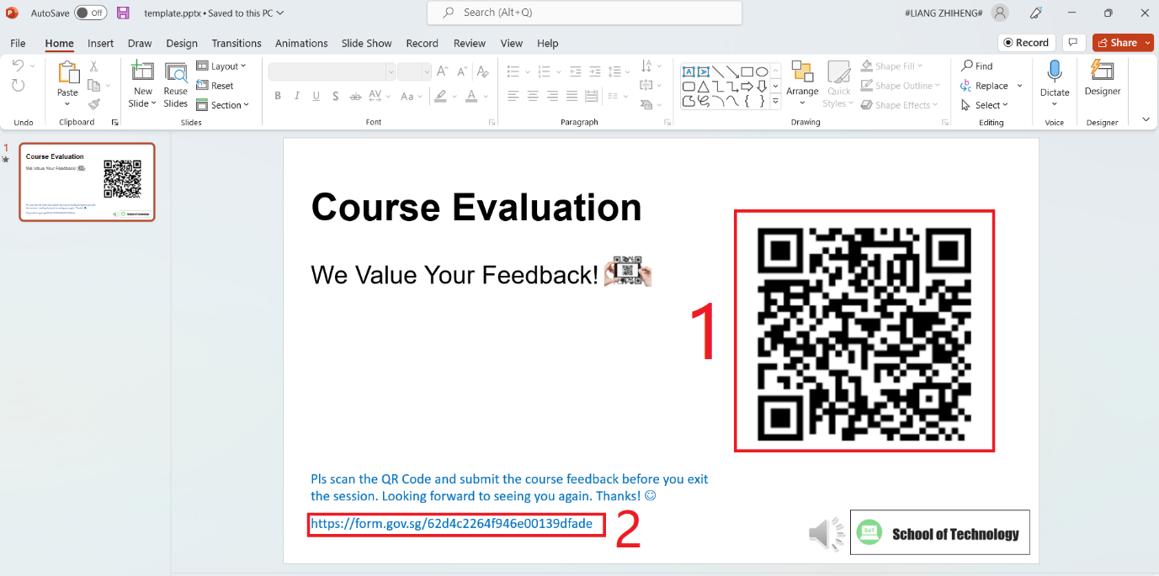

Figure 6. Overview of the template.pptx

The above is the overview of template.pptx. If I want to make the QR code labelled as 1 and the text box labelled as 2 become dynamic, I will do the following steps.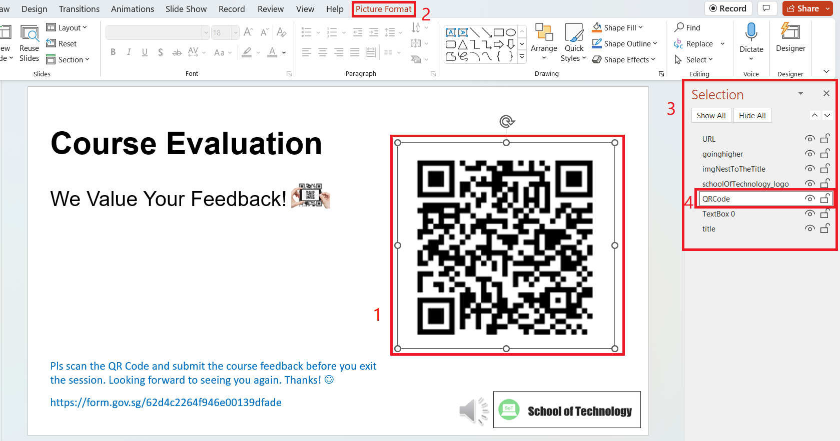

Figure 7. Steps for changing objects to dynamic

1. Make sure the slide that contains dynamic object is the first slide
2. Select the object that you want to change
3. Your screen should be look like figure 7
4. Click 1 then 2
5. Go to 3 and change 4
6. Make sure the QR code named as QRCode, the text box named as URL
7. Save the PowerPoint and name it as template.pptx